
NAME : STEPHEN KIMANI
ADMMISSION: BSCCS/2024/57444
COURSE : BACHELOR OF SCIENCE IN COMPUTER SCIENCE
UNIT CODE: BIT 4138
UNIT NAME: ADVANCED CRYPTOGRAPHY
LECTURER: MICHAEL NYORO
SEMESTER /ACADEMIC YEAR: SEMESTER 6
PROJECT DETAILS: IMPLEMENATION AND ANALYSIS OF CRYPTOGRAPHIC ALGORITHMS USING PYTHON
Technologies Used:
- Python 3
- Visual Studio Code
- Git
- OpenSSL
- PyCryptodome
- Windows PowerShell / Command Prompt

ONLINE PORTFOLIO/ GITHUB LINK
https://github.com/Kimani985/BIT4138-Advanced-Cryptography

Contents
WEEK 1: Cryptography Environment Setup 5
Installation and Configuration of Cryptography Development Environment 5
Figure 1: Successful installation of Python and Visual Studio Code for developing and testing cryptographic applications 5
Figure 2: Installation of cryptography libraries using pip, enabling implementation of encryption and decryption algorithms. 6
Figure 3: OpenSSL version verification confirming successful configuration of cryptographic command-line tools. 6
Figure 4: Execution of a Python test script verifying the development environment is operational. 7
Figure 5: Initialization of GitHub repository for version control and project documentation. 8
CREATIVE TASK - Environment Checker 8
Figure 6: Automated environment verification tool displaying the installed versions of Python, Git, and OpenSSL to confirm system readiness for cryptographic development. 8
Reflection 9
WEEK 2: Classical Cryptography and Cipher Design 10
Implementation of Classical Encryption Algorithms 10
Figure 7: Caesar Cipher implementation demonstrating character shifting using a fixed encryption key. 10
Figure 8: Successful encryption and decryption outputs generated by the implemented cipher algorithm. 11
Figure 9: Input validation process preventing invalid plaintext entries during encryption. 12
Figure 10: Vigenère Cipher implementation demonstrating keyword-based encryption. 13
Figure 11: Cipher testing results obtained using different messages and encryption keys. 13
CREATIVE TASK - Cryptography Toolkit 13
Figure 12: Interactive cryptography toolkit providing a menu-driven interface for selecting and executing classical encryption algorithms. 13
Reflection 13
WEEK 3: Stream Ciphers and Randomness Testing 14
Implementation of Stream Cipher Systems and Random Sequence Analysis 14
Figure 13: Implementation of a Linear Feedback Shift Register (LFSR) used to generate pseudorandom sequences. 14
Figure 14: Generated pseudorandom binary sequence produced by the implemented LFSR. 14
Figure 15: Statistical randomness testing results showing distribution of generated binary values. 15
Figure 16: RC4-style stream cipher simulation demonstrating encryption using a generated keystream. 15
Figure 17: Performance evaluation results showing execution time during encryption operations. 16
CREATIVE TASK- Randomness Challenge Game 16
Figure 18: Interactive Randomness Challenge Game demonstrating binary sequence generation, user prediction, and statistical analysis of pseudorandom output. 16
Reflection 16
WEEK 4: Block Cipher Design and AES 17
Advanced Encryption Standard (AES) and Block Cipher Operations 17
Figure 19: AES encryption program implementing symmetric key cryptography for secure file protection 17
Figure 20: AES symmetric key generation process used for encryption and decryption operations 18
Figure 21: Successful encryption of a text file using the generated AES key. 18
Figure 22: Successful decryption process restoring the original file contents. 18
Figure 23: AES performance evaluation showing execution time during encryption 19
CREATIVE TASK - Secure File Locker 19
Figure 24: Secure File Locker demonstrating user-driven AES encryption and successful recovery of encrypted file contents through decryption. 19
Reflection 19
WEEK 5: Public Key Cryptography (RSA) 20
Implementation of RSA encryption and Key Management 20
Figure 25: Generation of RSA public and private key pairs used for secure communication. 20
Figure 26: Encryption of plaintext using the RSA public key. 20
Figure 27: Successful recovery of the original message using the RSA private key. 21
Figure 28: Simulation of secure communication using RSA public and private key cryptography. 21
Figure 29: RSA testing and validation confirming successful encryption and decryption operations. 21
CREATIVE TASK - Secure RSA Messenger 22
Figure 30: Secure RSA Messenger demonstrating encrypted communication between Alice and Bob through RSA public-key encryption and private-key decryption. 22
Reflection 22
WEEK 6 - SPN, S-Boxes and Non-Linearity 23
Class Activity 1: Manual SPN Simulation 23
Figure 31: Manual SPN simulation showing substitution and permutation across two rounds. 23
Class Activity 2 – S-Box Analysis 23
Figure 32 : S-Box analysis showing mapping uniqueness and security evaluation 23
Figure 33: Feistel and SPN structure comparison. 24
Implementation of a Simple Substitution-Permutation Network (SPN) 24
Figure 34: Simple SPN cipher implementation and execution. 24
CREATIVE TASK 1 - SPN Visualizer 25
Figure 35: SPN Visualizer illustrating the step-by-step transformation of plaintext through substitution and permutation stages to produce ciphertext. 25
Creative Task 2 - Avalanche Effect Analyzer 25
Figure 36: Avalanche Effect Analyzer showing input difference analysis. 25
REFLECTION 26
WEEK 7 - Cryptanalysis Techniques 27
Class Activity 1: Difference Analysis 27
Figure 37:Difference analysis implementation and execution. 27
Class Activity 2: Frequency Analysis 27
Figure 38 : Frequency analysis showing character occurrence counts. 27
Class Activity 3: Probability Analysis 28
Figure 39: Probability analysis showing likelihood calculation. 28
Class Activity 4: Differential Cryptanalysis Simulation 29
Figure 40:Differential cryptanalysis simulation showing plaintext differences. 29
CREATIVE TASK – Cryptanalysis Toolkit 30
Figure 41: Cryptanalysis Toolkit integrating difference, frequency, and probability analysis techniques. 30
REFLECTION 30

WEEK 1: Cryptography Environment Setup

Installation and Configuration of Cryptography Development Environment
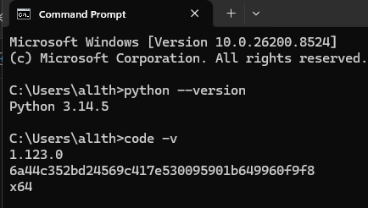
Figure 1: Successful installation of Python and Visual Studio Code for developing and testing cryptographic applications.

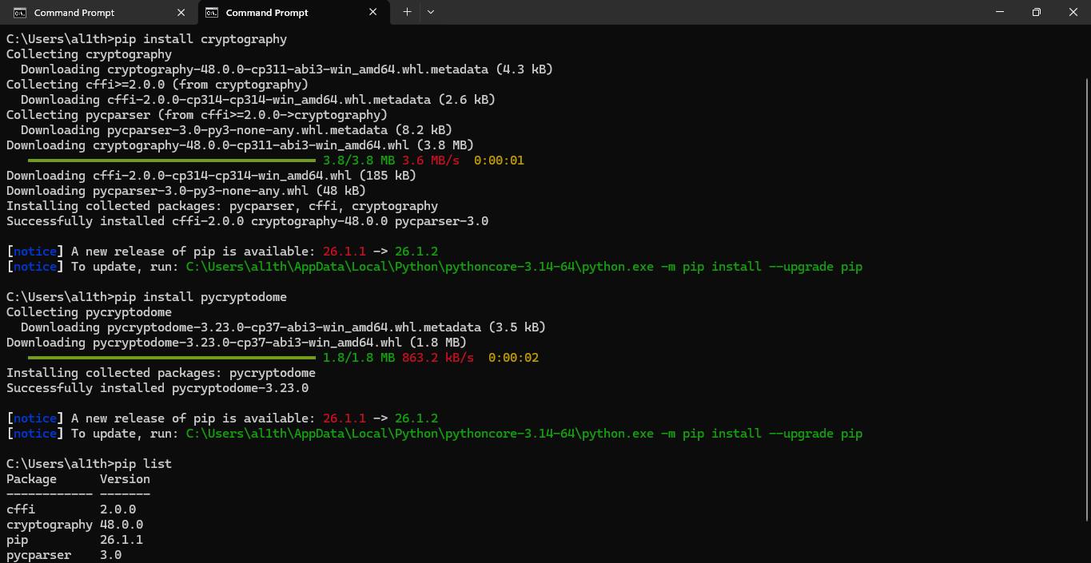

Figure 2: Installation of cryptography libraries using pip, enabling implementation of encryption and decryption algorithms.
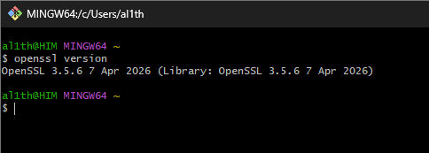

Figure 3: OpenSSL version verification confirming successful configuration of cryptographic command-line tools.

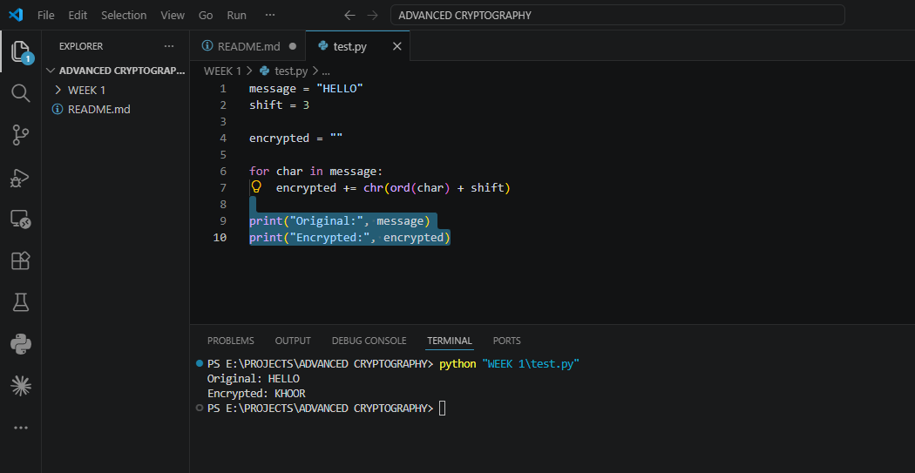

Figure 4: Execution of a Python test script verifying the development environment is operational.

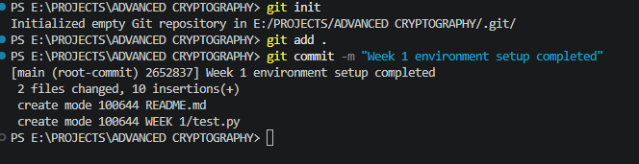

Figure 5: Initialization of GitHub repository for version control and project documentation.

CREATIVE TASK - Environment Checker
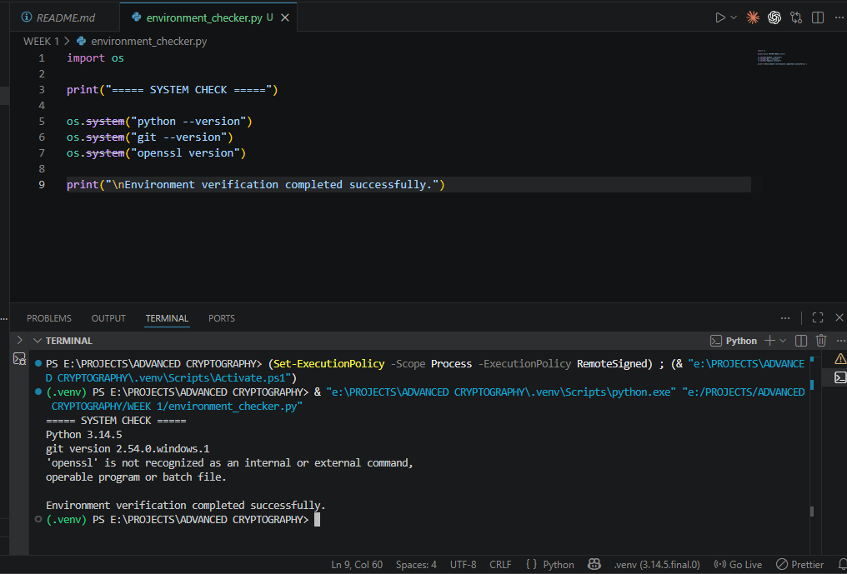

Figure 6: Automated environment verification tool displaying the installed versions of Python, Git, and OpenSSL to confirm system readiness for cryptographic development.

Reflection
This week focused on setting up the cryptography development environment. Python, VS Code, OpenSSL, and required libraries were successfully installed and tested. GitHub was configured for version control. The environment is now ready for implementing and testing cryptographic algorithms.

WEEK 2: Classical Cryptography and Cipher Design

Implementation of Classical Encryption Algorithms
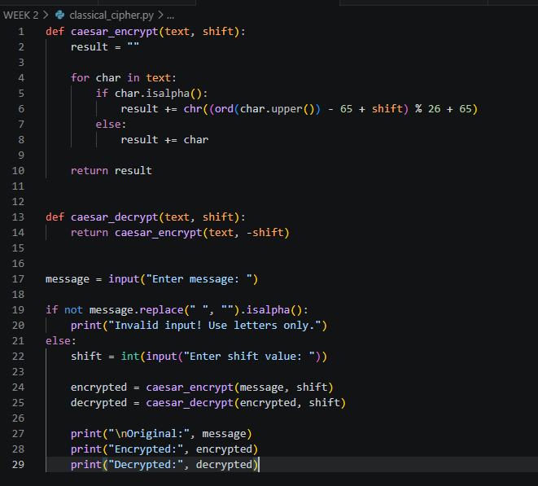

Figure 7: Caesar Cipher implementation demonstrating character shifting using a fixed encryption key.
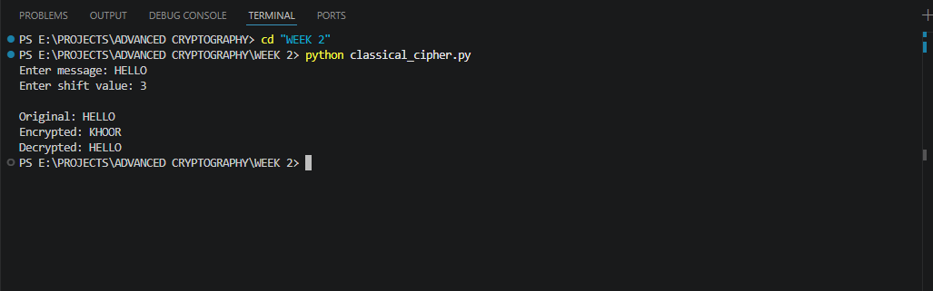

Figure 8: Successful encryption and decryption outputs generated by the implemented cipher algorithm.

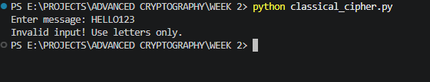

Figure 9: Input validation process preventing invalid plaintext entries during encryption.
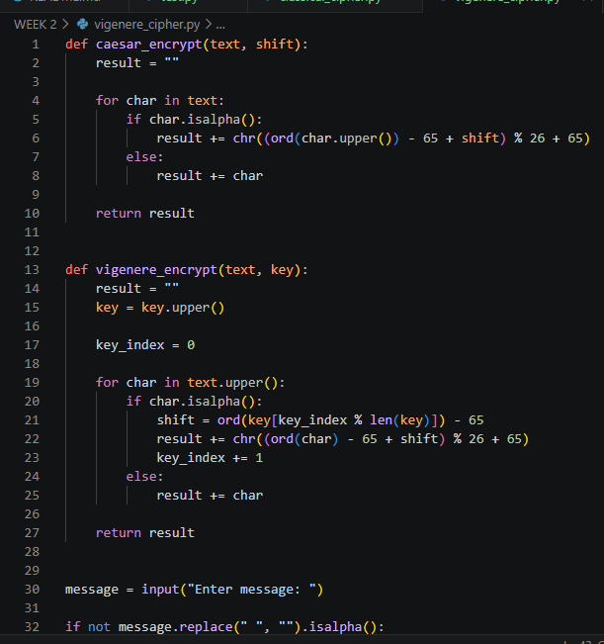

Figure 10: Vigenère Cipher implementation demonstrating keyword-based encryption.
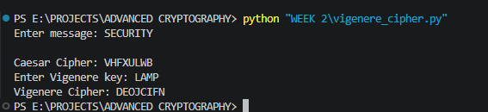

Figure 11: Cipher testing results obtained using different messages and encryption keys.

CREATIVE TASK - Cryptography Toolkit
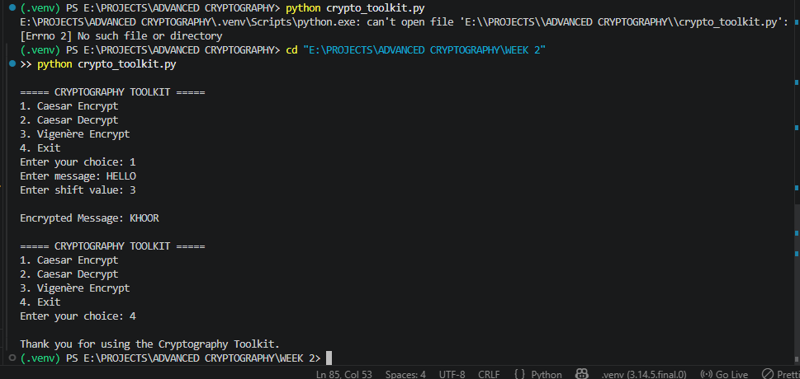

Figure 12: Interactive cryptography toolkit providing a menu-driven interface for selecting and executing classical encryption algorithms.

Reflection
The implementation of Caesar and Vigenère ciphers demonstrated the importance of encryption keys in protecting information. Testing showed that Vigenère Cipher provides stronger security through keyword-based encryption, while Caesar Cipher remains vulnerable to simple cryptanalysis techniques.

WEEK 3: Stream Ciphers and Randomness Testing

Implementation of Stream Cipher Systems and Random Sequence Analysis

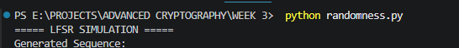

Figure 13: Implementation of a Linear Feedback Shift Register (LFSR) used to generate pseudorandom sequences.

Figure 14: Generated pseudorandom binary sequence produced by the implemented LFSR.

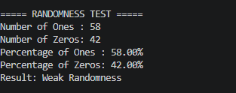

Figure 15: Statistical randomness testing results showing distribution of generated binary values.
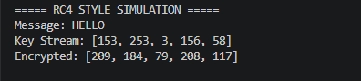

Figure 16: RC4-style stream cipher simulation demonstrating encryption using a generated keystream.
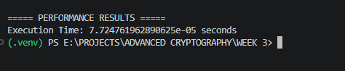

Figure 17: Performance evaluation results showing execution time during encryption operations.

CREATIVE TASK- Randomness Challenge Game
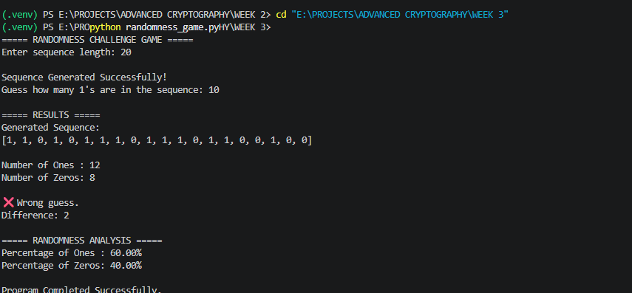

Figure 18: Interactive Randomness Challenge Game demonstrating binary sequence generation, user prediction, and statistical analysis of pseudorandom output.

Reflection
This week focused on pseudorandom sequence generation and stream cipher concepts. An LFSR was implemented to generate binary sequences, and statistical testing was performed to evaluate randomness. An RC4-style simulation demonstrated how stream ciphers use keystreams to encrypt data efficiently.

WEEK 4: Block Cipher Design and AES

Advanced Encryption Standard (AES) and Block Cipher Operations
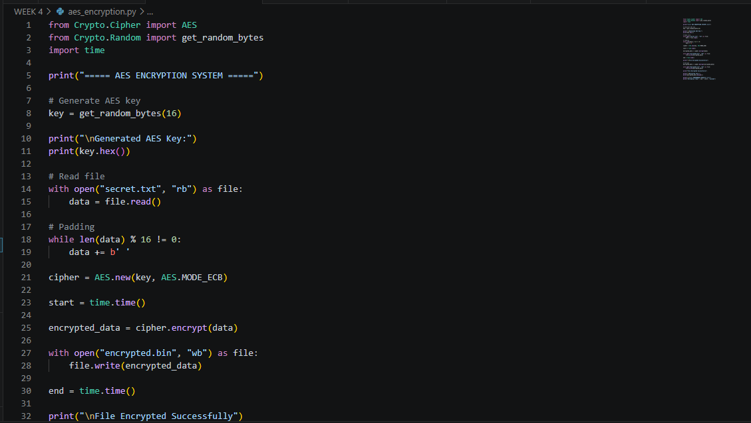

Figure 19: AES encryption program implementing symmetric key cryptography for secure file protection

Figure 20: AES symmetric key generation process used for encryption and decryption operations
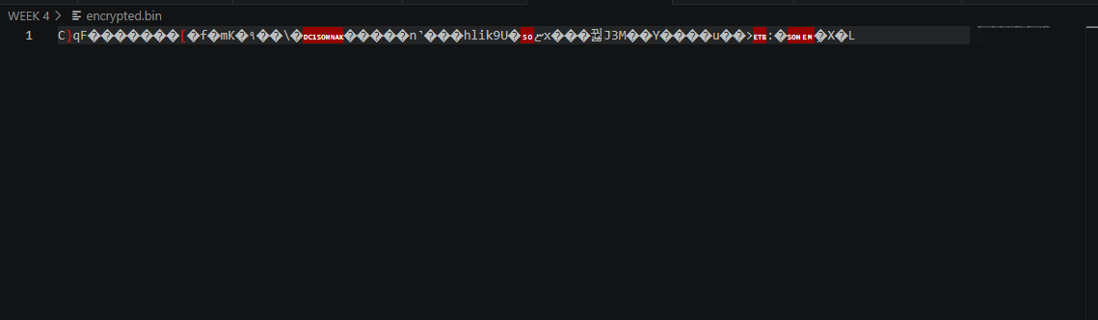

Figure 21: Successful encryption of a text file using the generated AES key.
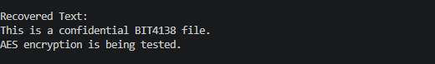

Figure 22: Successful decryption process restoring the original file contents.

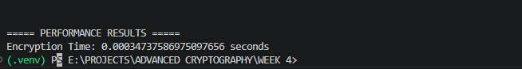
Figure 23: AES performance evaluation showing execution time during encryption.

CREATIVE TASK - Secure File Locker
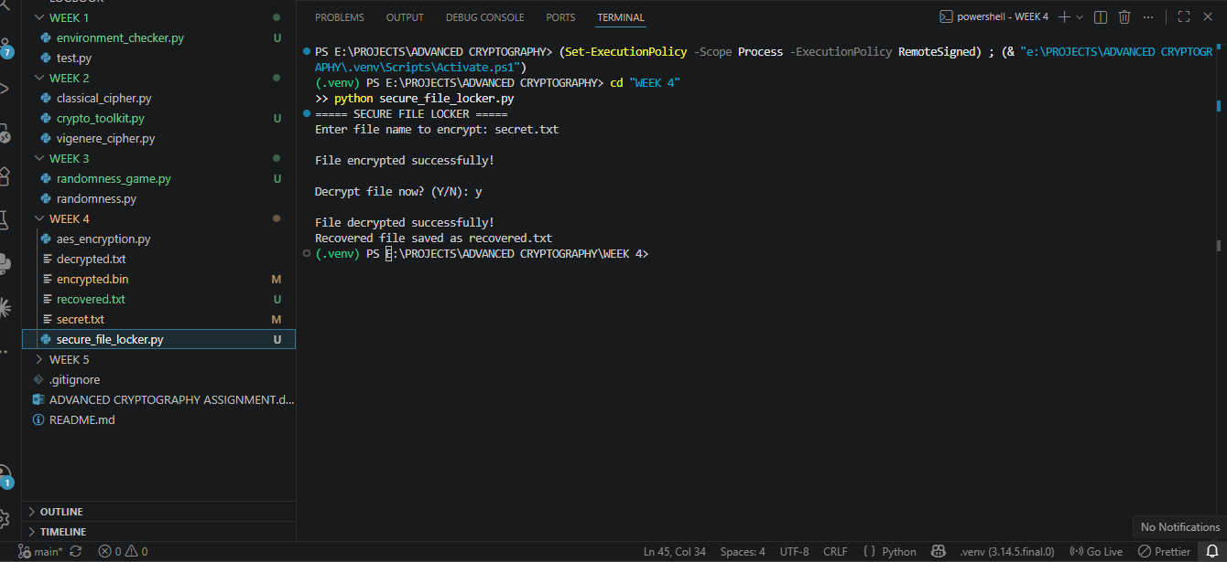

Figure 24: Secure File Locker demonstrating user-driven AES encryption and successful recovery of encrypted file contents through decryption.

Reflection
AES encryption was implemented to protect files using symmetric cryptography. Secure key generation, encryption, and decryption processes were successfully tested. The practical activity demonstrated the importance of key management and the effectiveness of AES in securing sensitive information.

WEEK 5: Public Key Cryptography (RSA)

Implementation of RSA encryption and Key Management
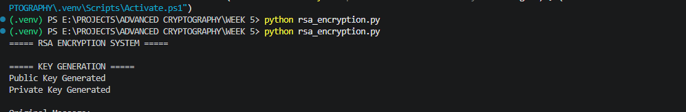

Figure 25: Generation of RSA public and private key pairs used for secure communication.
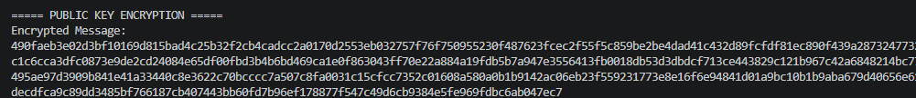

Figure 26: Encryption of plaintext using the RSA public key.
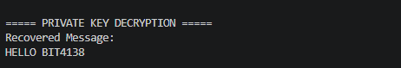

Figure 27: Successful recovery of the original message using the RSA private key.
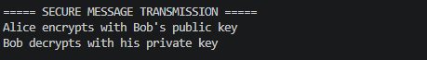

Figure 28: Simulation of secure communication using RSA public and private key cryptography.
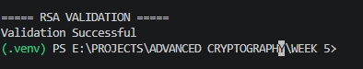

Figure 29: RSA testing and validation confirming successful encryption and decryption operations.

CREATIVE TASK - Secure RSA Messenger
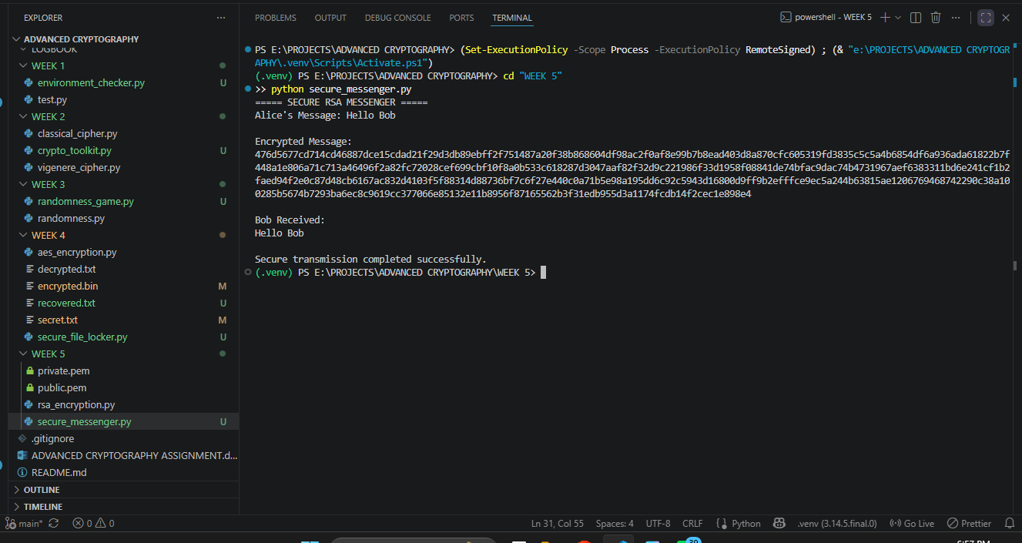

Figure 30: Secure RSA Messenger demonstrating encrypted communication between Alice and Bob through RSA public-key encryption and private-key decryption.

Reflection
RSA encryption demonstrated the use of public and private keys for secure communication. The Secure RSA Messenger successfully encrypted and decrypted messages, highlighting the practical application of asymmetric cryptography.

WEEK 6 - SPN, S-Boxes and Non-Linearity

Class Activity 1: Manual SPN Simulation
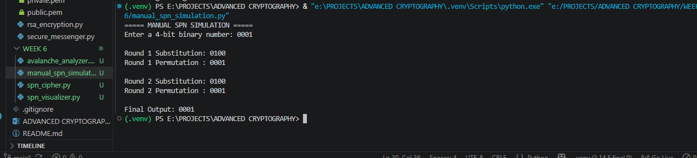

Figure 31: Manual SPN simulation showing substitution and permutation across two rounds.

Class Activity 2 – S-Box Analysis
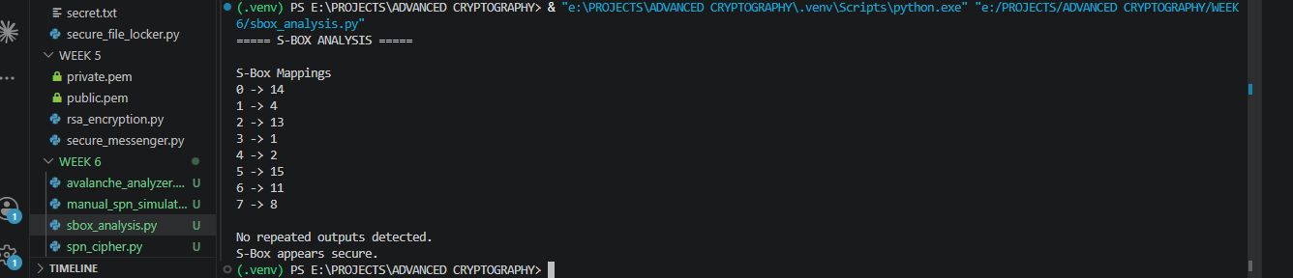

Figure 32 : S-Box analysis showing mapping uniqueness and security evaluation

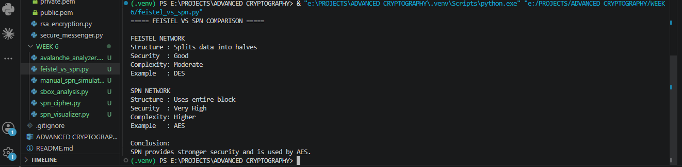

Figure 33: Feistel and SPN structure comparison.

Implementation of a Simple Substitution-Permutation Network (SPN)
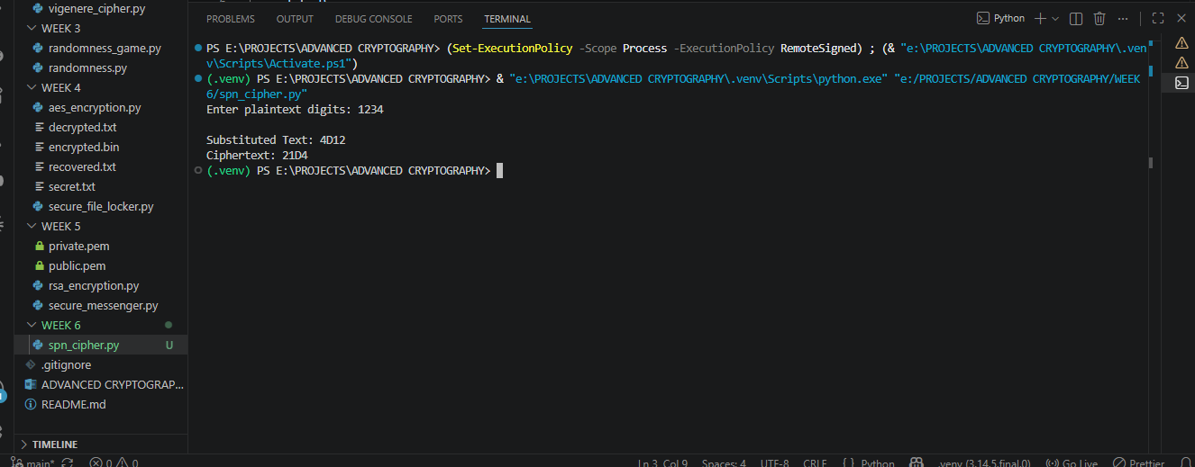

Figure 34: Simple SPN cipher implementation and execution.

CREATIVE TASK 1 - SPN Visualizer
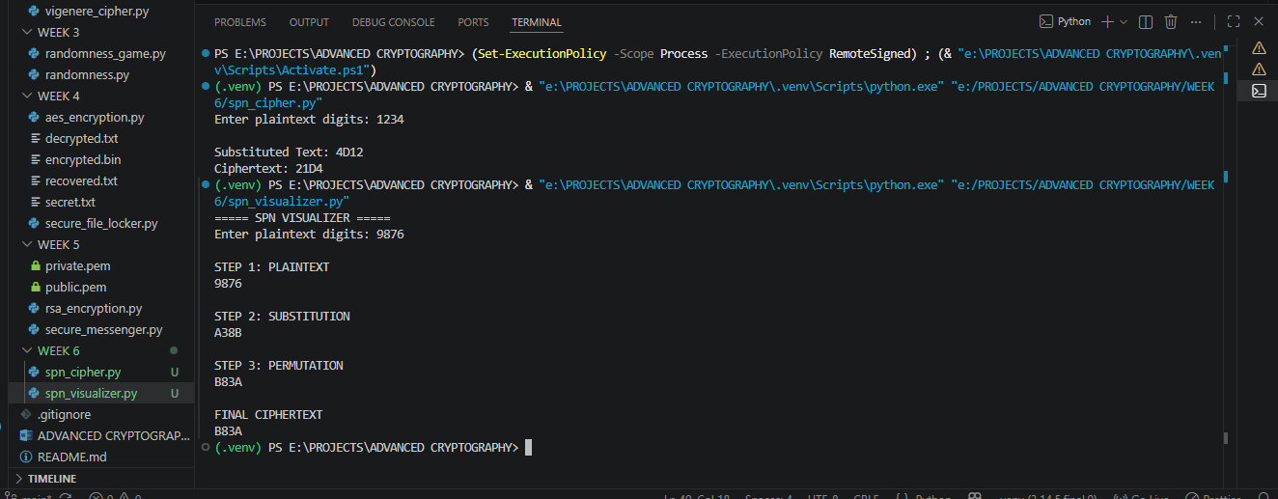

Figure 35: SPN Visualizer illustrating the step-by-step transformation of plaintext through substitution and permutation stages to produce ciphertext.

Creative Task 2 - Avalanche Effect Analyzer
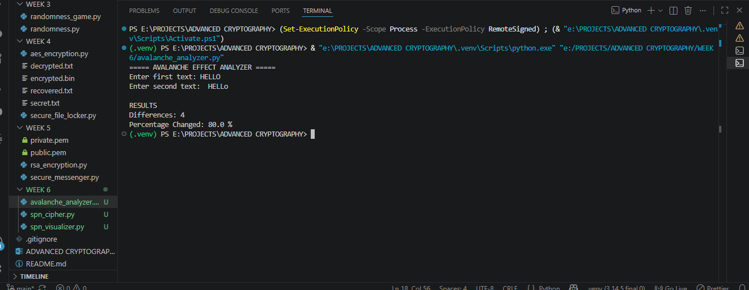

Figure 36: Avalanche Effect Analyzer showing input difference analysis.

REFLECTION
Week 6 explored Substitution-Permutation Networks through manual simulations, S-Box analysis, and SPN implementation. The creative tasks enhanced understanding of cipher structure and demonstrated how small input changes can influence cryptographic outputs.

WEEK 7 - Cryptanalysis Techniques

Class Activity 1: Difference Analysis
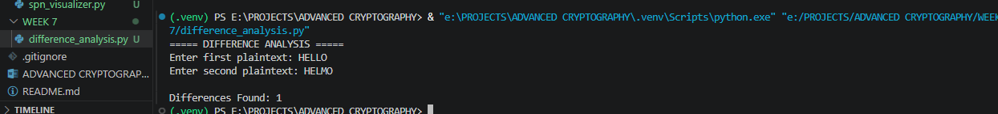

Figure 37:Difference analysis implementation and execution.

Class Activity 2: Frequency Analysis
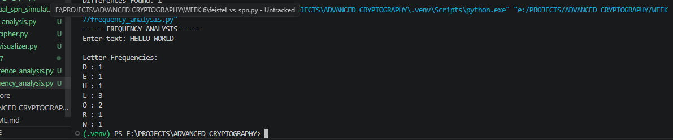

Figure 38 : Frequency analysis showing character occurrence counts.

Class Activity 3: Probability Analysis
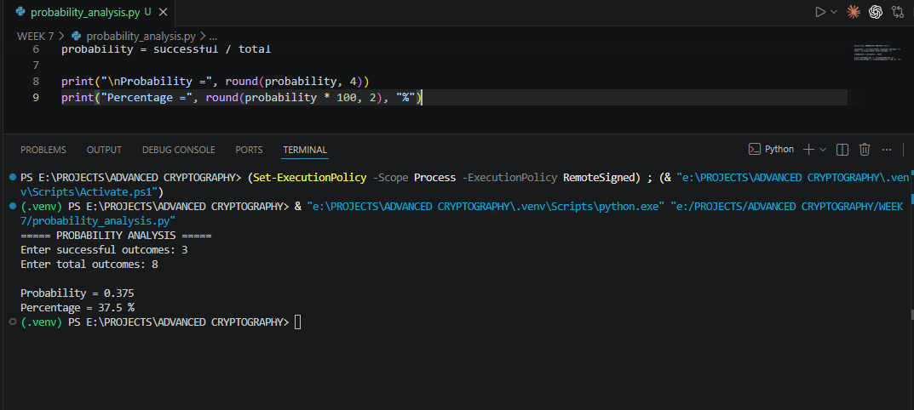

Figure 39: Probability analysis showing likelihood calculation.

Class Activity 4: Differential Cryptanalysis Simulation
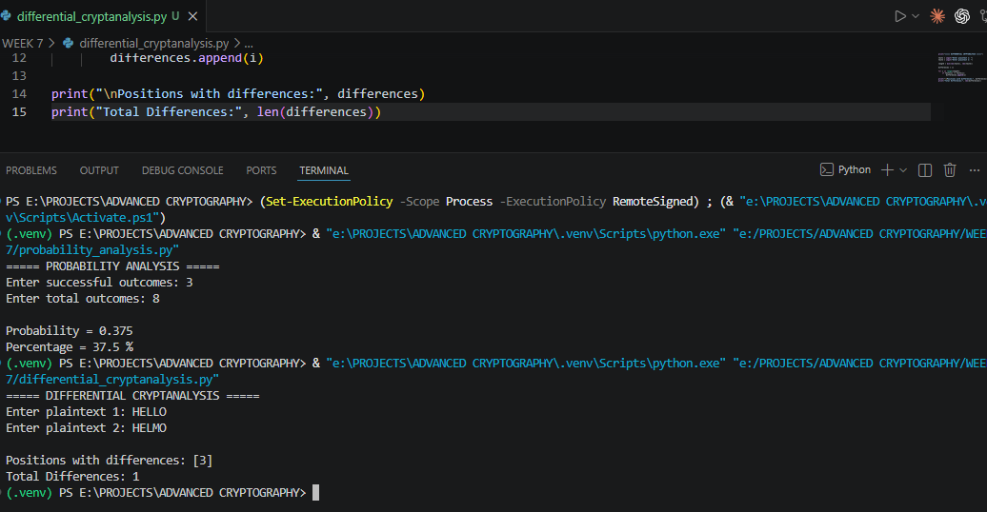

Figure 40:Differential cryptanalysis simulation showing plaintext differences.

CREATIVE TASK – Cryptanalysis Toolkit
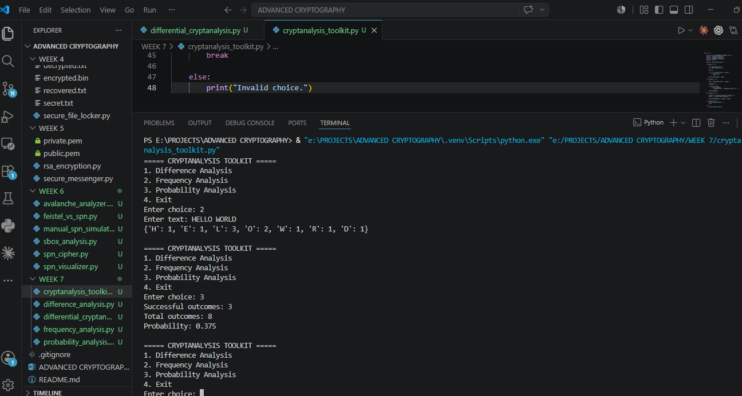

Figure 41: Cryptanalysis Toolkit integrating difference, frequency, and probability analysis techniques.

REFLECTION
Week 7 explored cryptanalysis techniques including difference analysis, frequency analysis, probability calculations, and differential cryptanalysis. The Cryptanalysis Toolkit combined these methods into a single application, improving understanding of how cryptographic systems can be evaluated and attacked.

